Chapter 2 p.34

Password based attacks spiked in 2023

Line graph showing Password based attacks over the years. X-axis represents the period from Jun 2020 to Jun 2023 and y-axis represents billions from 0 to 50 in intervals of 10. Line starts from almost 0 in Jun 20, remains constant till 2022, and shows a sharp growth to approx. 45 billion in May 23.

After a notable increase in the number of password-based attacks per month in October 2022, the number skyrocketed in 2023. In April, there were 11,000 attacks per second, a tenfold increase from the same time last year.

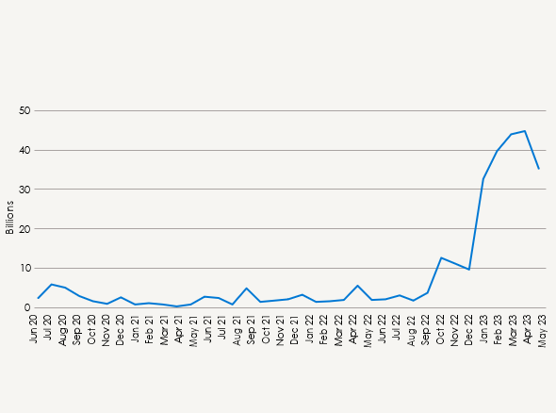

Source: Microsoft Entra data